**DBMS MINI PROJECT: Electricity Billing Management System (EBMS)**

**Submitted by:**

**Surya S (312322205177)**

**Sivachidambaram K S (312322205169)**

**Of**

**BACHELOR OF TECHNOLOGY**

**In**

**INFORMATION TECHNOLOGY**



**St. JOSEPH’S COLLEGE OF ENGINEERING**

**(An Autonomous Institution)**

**St. Joseph’s Group of Institutions**

**OMR, Chennai 600 119**

**TABLE OF CONTENTS**

|  |  |  |
| --- | --- | --- |
| CHAPTER | TITLE | PAGE NO. |
| 1. | ABSTRACT | 3 |
| 2. | INTRODUCTION | 3 |
| 3. | PROGRAM | 4 – 9 |
| 4. | WORKFLOW DIAGRAM | 10 |
| 5. | RESULT | 10 - 13 |
| 6. | CONCLUSION | 13 |

**Abstract:**

The Electricity Billing Management System (EBMS) is a pivotal component in modern utility infrastructure, ensuring accurate billing, efficient customer management, and streamlined administrative processes. This project presents a comprehensive database management system (DBMS) tailored specifically for EBMS. By integrating robust database architecture with intuitive user interfaces, the system aims to revolutionize the management of electricity billing operations.

**Introduction:**

Electricity billing is a critical aspect of utility services, requiring meticulous attention to detail and efficient handling of vast amounts of data. Traditional manual methods are prone to errors and inefficiencies, necessitating the adoption of automated systems. This project introduces a sophisticated DBMS for EBMS, offering a centralized platform for managing customer accounts, billing information, tariffs, and administrative tasks. Through the implementation of advanced database technologies, this system seeks to enhance accuracy, reliability, and user accessibility.

Program:

-- MySQL dump 10.13  Distrib 8.0.24, for Win64 (x86_64)

--

-- Host: localhost    Database: ebms

-- ------------------------------------------------------

-- Server version 8.0.24

/*!40101 SET @OLD_CHARACTER_SET_CLIENT=@@CHARACTER_SET_CLIENT */;

/*!40101 SET @OLD_CHARACTER_SET_RESULTS=@@CHARACTER_SET_RESULTS */;

/*!40101 SET @OLD_COLLATION_CONNECTION=@@COLLATION_CONNECTION */;

/*!50503 SET NAMES utf8mb4 */;

/*!40103 SET @OLD_TIME_ZONE=@@TIME_ZONE */;

/*!40103 SET TIME_ZONE='+00:00' */;

/*!40014 SET @OLD_UNIQUE_CHECKS=@@UNIQUE_CHECKS, UNIQUE_CHECKS=0 */;

/*!40014 SET @OLD_FOREIGN_KEY_CHECKS=@@FOREIGN_KEY_CHECKS, FOREIGN_KEY_CHECKS=0 */;

/*!40101 SET @OLD_SQL_MODE=@@SQL_MODE, SQL_MODE='NO_AUTO_VALUE_ON_ZERO' */;

/*!40111 SET @OLD_SQL_NOTES=@@SQL_NOTES, SQL_NOTES=0 */;

--

-- Table structure for table `account`

--

DROP TABLE IF EXISTS `account`;

/*!40101 SET @saved_cs_client     = @@character_set_client */;

/*!50503 SET character_set_client = utf8mb4 */;

CREATE TABLE `account` (

  `acc_id` int NOT NULL,

  `cust_id` int DEFAULT NULL,

  `account_no` varchar(50) DEFAULT NULL,

  `name` varchar(50) NOT NULL,

  PRIMARY KEY (`acc_id`),

  KEY `cust_id` (`cust_id`),

  CONSTRAINT `account_ibfk_1` FOREIGN KEY (`cust_id`) REFERENCES `customer` (`cust_id`)

) ENGINE=InnoDB DEFAULT CHARSET=utf8mb4 COLLATE=utf8mb4_0900_ai_ci;

/*!40101 SET character_set_client = @saved_cs_client */;

--

-- Dumping data for table `account`

--

LOCK TABLES `account` WRITE;

/*!40000 ALTER TABLE `account` DISABLE KEYS */;

INSERT INTO `account` VALUES (401,111,'11345','Abhay'),(403,112,'12455','Vishnu'),(405,113,'98754','Anant'),(407,211,'34557','Vijay'),(409,212,'24567','Deekshith'),(411,311,'76314','Farhaan'),(413,312,'54327','Ajay'),(415,313,'74123','Nikhil'),(417,411,'43567','Preetham'),(419,412,'98764','Sridhar'),(421,345,'43561','Rohanjit'),(423,325,'78654','Ayushman'),(425,347,'67452','Anwesh'),(427,367,'91294','Devash'),(429,324,'89123','Tushar');

/*!40000 ALTER TABLE `account` ENABLE KEYS */;

UNLOCK TABLES;

--

-- Table structure for table `admin`

--

DROP TABLE IF EXISTS `admin`;

/*!40101 SET @saved_cs_client     = @@character_set_client */;

/*!50503 SET character_set_client = utf8mb4 */;

CREATE TABLE `admin` (

  `admin_id` int NOT NULL,

  `admin_name` varchar(50) NOT NULL,

  `cust_id` int DEFAULT NULL,

  PRIMARY KEY (`admin_id`),

  KEY `cust_id` (`cust_id`),

  CONSTRAINT `admin_ibfk_1` FOREIGN KEY (`cust_id`) REFERENCES `customer` (`cust_id`)

) ENGINE=InnoDB DEFAULT CHARSET=utf8mb4 COLLATE=utf8mb4_0900_ai_ci;

/*!40101 SET character_set_client = @saved_cs_client */;

--

-- Dumping data for table `admin`

--

LOCK TABLES `admin` WRITE;

/*!40000 ALTER TABLE `admin` DISABLE KEYS */;

INSERT INTO `admin` VALUES (1,'Sahil',111),(2,'Karan',112),(3,'Rahul',113),(4,'Nikhil',211),(5,'Sushmitha',212),(6,'Priyanka',311),(7,'Shikha',312),(8,'Ritesh',313),(9,'Aman',411),(10,'Nitin',412),(11,'Akshat',345),(12,'Ankit',325),(13,'Shashi',347),(14,'Ritika',367),(15,'Kamchin',324);

/*!40000 ALTER TABLE `admin` ENABLE KEYS */;

UNLOCK TABLES;

--

-- Table structure for table `billing`

--

DROP TABLE IF EXISTS `billing`;

/*!40101 SET @saved_cs_client     = @@character_set_client */;

/*!50503 SET character_set_client = utf8mb4 */;

CREATE TABLE `billing` (

  `meter_number` varchar(10) NOT NULL,

  `acc_id` int DEFAULT NULL,

  `cust_id` int DEFAULT NULL,

  `monthly_units` int DEFAULT NULL,

  `amount_per_unit` int DEFAULT NULL,

  `total_amount` int DEFAULT NULL,

  PRIMARY KEY (`meter_number`),

  KEY `acc_id` (`acc_id`),

  KEY `cust_id` (`cust_id`),

  CONSTRAINT `billing_ibfk_1` FOREIGN KEY (`acc_id`) REFERENCES `account` (`acc_id`),

  CONSTRAINT `billing_ibfk_2` FOREIGN KEY (`cust_id`) REFERENCES `customer` (`cust_id`)

) ENGINE=InnoDB DEFAULT CHARSET=utf8mb4 COLLATE=utf8mb4_0900_ai_ci;

/*!40101 SET character_set_client = @saved_cs_client */;

--

-- Dumping data for table `billing`

--

LOCK TABLES `billing` WRITE;

/*!40000 ALTER TABLE `billing` DISABLE KEYS */;

INSERT INTO `billing` VALUES ('101',401,111,500,10,5000),('102',403,112,390,10,3900),('103',405,113,208,10,2080),('104',407,211,800,10,8000),('105',409,212,200,10,2000),('106',411,311,600,10,6000),('107',413,312,250,10,2500),('108',415,313,400,10,4000),('109',417,411,450,10,4500),('110',419,412,550,10,5500),('111',421,345,320,10,3200),('112',423,325,590,10,5900),('113',425,347,670,10,6700),('114',427,367,230,10,2300),('115',429,324,650,10,6500);

/*!40000 ALTER TABLE `billing` ENABLE KEYS */;

UNLOCK TABLES;

--

-- Table structure for table `customer`

--

DROP TABLE IF EXISTS `customer`;

/*!40101 SET @saved_cs_client     = @@character_set_client */;

/*!50503 SET character_set_client = utf8mb4 */;

CREATE TABLE `customer` (

  `cust_id` int NOT NULL,

  `cust_name` varchar(50) NOT NULL,

  `address` varchar(50) NOT NULL,

  `state` varchar(30) NOT NULL,

  `city` varchar(30) NOT NULL,

  `pincode` int NOT NULL,

  PRIMARY KEY (`cust_id`)

) ENGINE=InnoDB DEFAULT CHARSET=utf8mb4 COLLATE=utf8mb4_0900_ai_ci;

/*!40101 SET character_set_client = @saved_cs_client */;

--

-- Dumping data for table `customer`

--

LOCK TABLES `customer` WRITE;

/*!40000 ALTER TABLE `customer` DISABLE KEYS */;

INSERT INTO `customer` VALUES (111,'Abhay','MG Road','Karnataka','Mysore\n',570008),(112,'Vishnu','Basaveshwara Nagar','Karnataka','Bangalore',570042),(113,'Anant','HD Kote Road','Karnataka','Mysore',570009),(211,'Vijay','Devaraja Urs Road','Karnataka','Mysore',570034),(212,'Deekshith','RK Block','Karnataka','Tumkur',580054),(311,'Farhaan','KG Koppal','Karnataka','Mysore',570046),(312,'Ajay','Pamban Bridge Road','Tamil Nadu','Rameshwaram',590065),(313,'Nikhil','HSR Layout','Karnataka','Bangalore',570075),(324,'Tushar','MS Raod','Uttar Pradesh','Lucknow',640092),(325,'Ayushman','Kanakapura Road','Karnataka','Bangalore',570049),(345,'Rohanjit','Kuvempunagar','Karnataka','Mysore',570048),(347,'Anwesh','DFG Layout','Madhya Pradesh','Indore ',620089),(367,'Devash','Chambal Road','Tamil Nadu','Chennai',590068),(411,'Preetham','AB Block','Uttar Pradesh','Ayodhya',640055),(412,'Sridhar','Gwalior Road','Madhya Pradesh','Gwalior',620067);

/*!40000 ALTER TABLE `customer` ENABLE KEYS */;

UNLOCK TABLES;

--

-- Table structure for table `elec_board`

--

DROP TABLE IF EXISTS `elec_board`;

/*!40101 SET @saved_cs_client     = @@character_set_client */;

/*!50503 SET character_set_client = utf8mb4 */;

CREATE TABLE `elec_board` (

  `eboard_id` int NOT NULL,

  `board_name` varchar(50) DEFAULT NULL,

  PRIMARY KEY (`eboard_id`)

) ENGINE=InnoDB DEFAULT CHARSET=utf8mb4 COLLATE=utf8mb4_0900_ai_ci;

/*!40101 SET character_set_client = @saved_cs_client */;

--

-- Dumping data for table `elec_board`

--

LOCK TABLES `elec_board` WRITE;

/*!40000 ALTER TABLE `elec_board` DISABLE KEYS */;

INSERT INTO `elec_board` VALUES (1010,'Chamundeshwari Power Corporation'),(2010,'Karnataka Power Corporation'),(3010,'Bangalore Power Corporation'),(4010,'Tamil Nadu Power Corporation'),(5010,'Uttar Pradesh Power Corporation'),(6010,'Madhya Pradesh Power Corporation');

/*!40000 ALTER TABLE `elec_board` ENABLE KEYS */;

UNLOCK TABLES;

--

-- Table structure for table `invoice`

--

DROP TABLE IF EXISTS `invoice`;

/*!40101 SET @saved_cs_client     = @@character_set_client */;

/*!50503 SET character_set_client = utf8mb4 */;

CREATE TABLE `invoice` (

  `invoice_id` int NOT NULL,

  `eboard_id` int DEFAULT NULL,

  `account_no` varchar(50) DEFAULT NULL,

  `tariff_id` int DEFAULT NULL,

  `reading_date` date DEFAULT NULL,

  `Meter_number` varchar(10) DEFAULT NULL,

  PRIMARY KEY (`invoice_id`),

  KEY `eboard_id` (`eboard_id`),

  KEY `tariff_id` (`tariff_id`),

  KEY `Meter_number` (`Meter_number`),

  CONSTRAINT `invoice_ibfk_1` FOREIGN KEY (`eboard_id`) REFERENCES `elec_board` (`eboard_id`),

  CONSTRAINT `invoice_ibfk_2` FOREIGN KEY (`tariff_id`) REFERENCES `tariff` (`tariff_id`),

  CONSTRAINT `invoice_ibfk_3` FOREIGN KEY (`Meter_number`) REFERENCES `billing` (`meter_number`)

) ENGINE=InnoDB DEFAULT CHARSET=utf8mb4 COLLATE=utf8mb4_0900_ai_ci;

/*!40101 SET character_set_client = @saved_cs_client */;

--

-- Dumping data for table `invoice`

--

LOCK TABLES `invoice` WRITE;

/*!40000 ALTER TABLE `invoice` DISABLE KEYS */;

INSERT INTO `invoice` VALUES (1000,6010,'98764',12,'2020-06-10','110'),(1047,4010,'91294',15,'2020-06-03','114'),(1111,1010,'11345',12,'2020-06-23','101'),(1888,1010,'43561',15,'2020-06-26','111'),(1999,3010,'78654',13,'2020-06-18','112'),(2017,6010,'67452',12,'2020-06-09','113'),(2222,3010,'12455',13,'2020-06-17','102'),(3333,1010,'98754',12,'2020-06-22','103'),(4444,1010,'34557',14,'2020-06-14','104'),(5555,2010,'24567',15,'2020-06-21','105'),(6666,1010,'76314',13,'2020-06-05','106'),(7777,4010,'54327',14,'2020-06-11','107'),(8014,5010,'89123',15,'2020-06-06','115'),(8888,3010,'74123',12,'2020-06-12','108'),(9999,5010,'43567',14,'2020-06-13','109');

/*!40000 ALTER TABLE `invoice` ENABLE KEYS */;

UNLOCK TABLES;

--

-- Table structure for table `tariff`

--

DROP TABLE IF EXISTS `tariff`;

/*!40101 SET @saved_cs_client     = @@character_set_client */;

/*!50503 SET character_set_client = utf8mb4 */;

CREATE TABLE `tariff` (

  `tariff_id` int NOT NULL,

  `tariff_type` varchar(50) DEFAULT NULL,

  PRIMARY KEY (`tariff_id`)

) ENGINE=InnoDB DEFAULT CHARSET=utf8mb4 COLLATE=utf8mb4_0900_ai_ci;

/*!40101 SET character_set_client = @saved_cs_client */;

--

-- Dumping data for table `tariff`

--

LOCK TABLES `tariff` WRITE;

/*!40000 ALTER TABLE `tariff` DISABLE KEYS */;

INSERT INTO `tariff` VALUES (12,'Power factor tariff'),(13,'Peak Load tariff'),(14,'Two part tariff'),(15,'Three part tariff');

/*!40000 ALTER TABLE `tariff` ENABLE KEYS */;

UNLOCK TABLES;

/*!40103 SET TIME_ZONE=@OLD_TIME_ZONE */;

/*!40101 SET SQL_MODE=@OLD_SQL_MODE */;

/*!40014 SET FOREIGN_KEY_CHECKS=@OLD_FOREIGN_KEY_CHECKS */;

/*!40014 SET UNIQUE_CHECKS=@OLD_UNIQUE_CHECKS */;

/*!40101 SET CHARACTER_SET_CLIENT=@OLD_CHARACTER_SET_CLIENT */;

/*!40101 SET CHARACTER_SET_RESULTS=@OLD_CHARACTER_SET_RESULTS */;

/*!40101 SET COLLATION_CONNECTION=@OLD_COLLATION_CONNECTION */;

/*!40111 SET SQL_NOTES=@OLD_SQL_NOTES */;

-- Dump completed on 2021-06-29 12:31:55

**Workflow Diagram:**

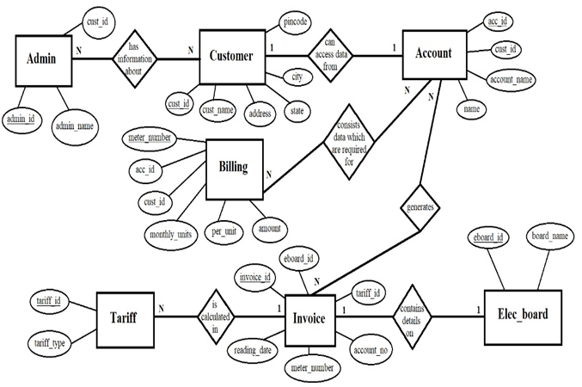

**Result:**

The implementation of the EBMS DBMS yields significant benefits in terms of operational efficiency, data accuracy, and user satisfaction. By automating billing processes and centralizing data management, the system minimizes errors, reduces administrative overhead, and enhances overall productivity. Customers benefit from accurate billing, transparent tariff structures, and streamlined account management processes. Administrators gain access to comprehensive tools for monitoring and managing system operations, thereby facilitating informed decision-making and strategic planning. Overall, the EBMS DBMS enhances the efficiency and effectiveness of electricity billing operations, contributing to the optimization of utility company services.

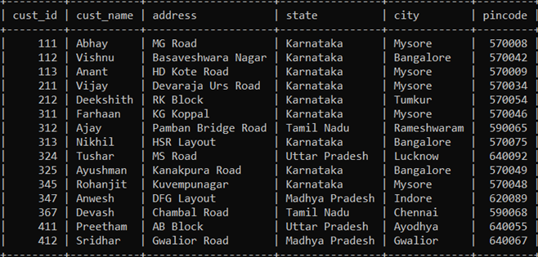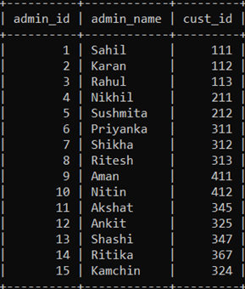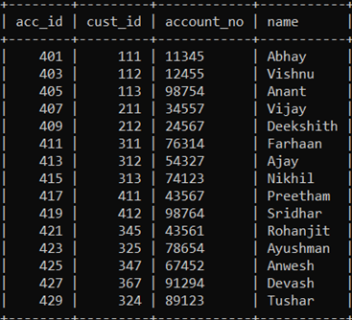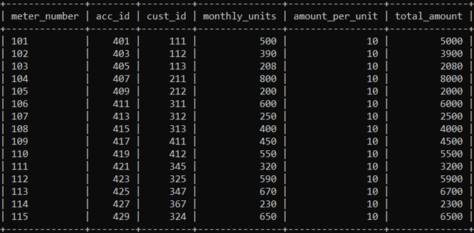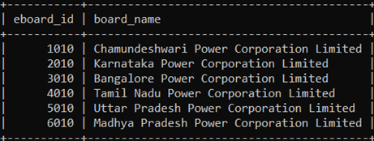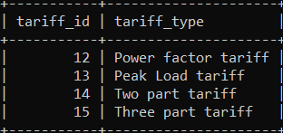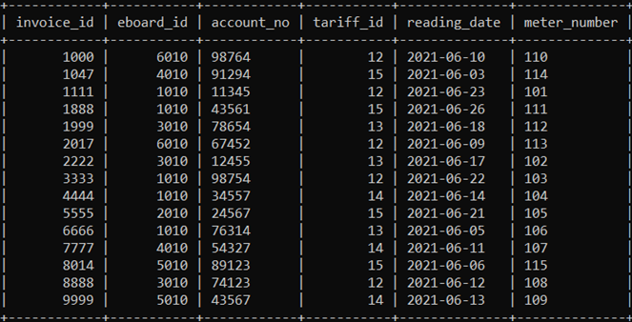

**Conclusion:**

In conclusion, the EBMS DBMS represents a paradigm shift in the management of electricity billing operations, offering a comprehensive solution for utility companies to optimize their service delivery. By leveraging advanced database technologies and intuitive user interfaces, the system streamlines billing processes, improves data accuracy, and enhances user experience. The implementation of EBMS DBMS underscores the importance of leveraging technology to address the evolving needs of utility infrastructure, ensuring reliable and efficient delivery of electricity services to customers.